Project Development Phase - Dashboard and Story
Project Title: Heart Disease Analysis
Tool: Tableau Desktop/Public

Dashboard Overview
This dashboard presents interactive visualizations to analyze heart disease risk factors. It combines demographic, lifestyle, and medical information to help identify patterns associated with heart disease.

Dashboard Objectives
- Analyze heart disease across gender and age groups.
- Study the impact of smoking and alcohol consumption.
- Compare diabetic status with stroke occurrence.
- Visualize race-wise heart disease distribution.
- Identify relationships between BMI, age, and diabetes.
- Support healthcare decision-making through interactive dashboards.

Dashboard 1 - Demographic & Lifestyle Analysis
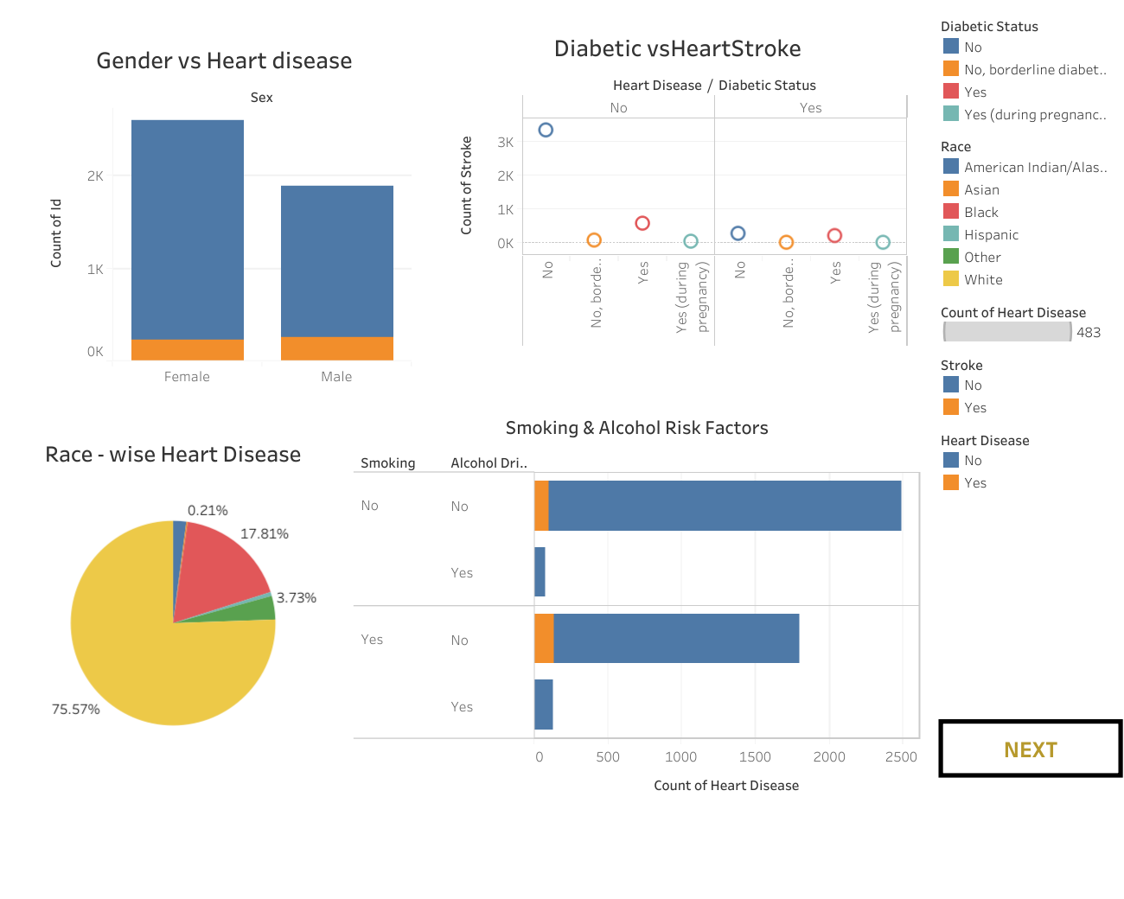
Figure 1: Dashboard showing Gender vs Heart Disease, Diabetic vs Stroke, Race-wise Heart Disease, and Smoking & Alcohol Risk Factors.

Insights
- Gender comparison highlights the distribution of heart disease among male and female patients.
- Race-wise analysis identifies the proportion of cases across different racial groups.
- Smoking and alcohol consumption are compared to understand lifestyle-related risks.
- Diabetic status is analyzed alongside stroke to identify coexisting health conditions.

Dashboard 2 - Health Status & BMI Analysis
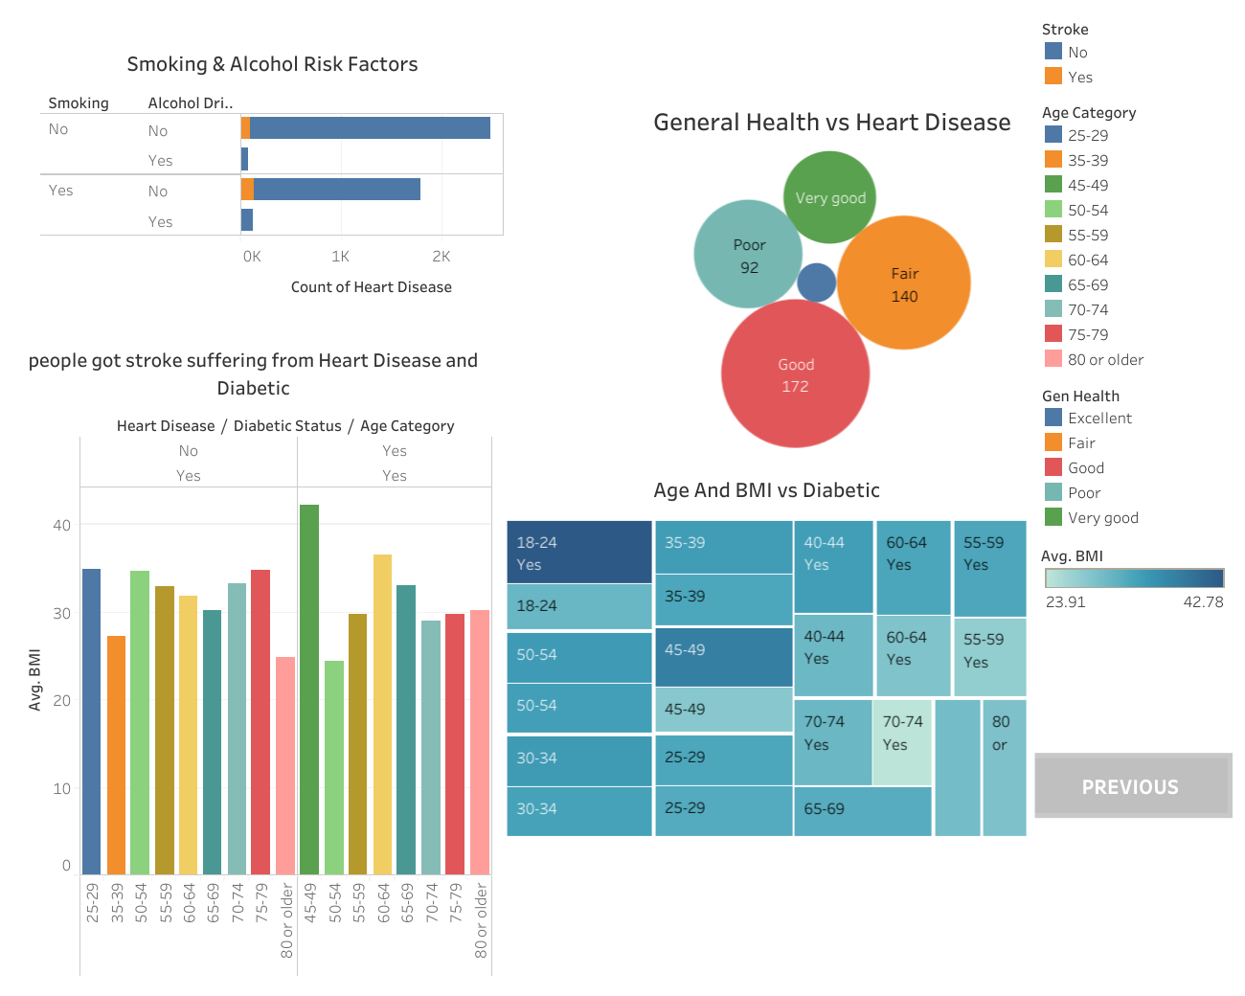
Figure 2: Dashboard showing General Health vs Heart Disease, Smoking & Alcohol Risk Factors, Age and BMI vs Diabetes, and BMI analysis for stroke and diabetic patients.

Insights
- General health categories show a relationship with heart disease occurrence.
- Treemap visualizes age and BMI patterns among diabetic patients.
- Average BMI across age groups helps identify obesity-related risk trends.
- Combined dashboard enables comparison of multiple health indicators simultaneously.

Business/Healthcare Benefits
- Supports early identification of high-risk patients.
- Helps healthcare professionals understand disease patterns.
- Enables evidence-based preventive healthcare planning.
- Improves communication of complex health data through interactive visualizations.

Conclusion
The dashboards convert complex healthcare data into clear visual insights, enabling users to explore relationships between demographic, lifestyle, and medical risk factors associated with heart disease.

